**FIRST SERIES EXAMINATION, FEBRUARY 2018**

**S6R COMPUTER SCIENCE & ENGINEERING DEPARTMENT**

**CS368 WEB TECHNOLOGIES**

**Time : 1 hr Answer key Max. Mark: 40**

1. Difference between the syntactic rules of HTML and XHTML. (any 8 difference)

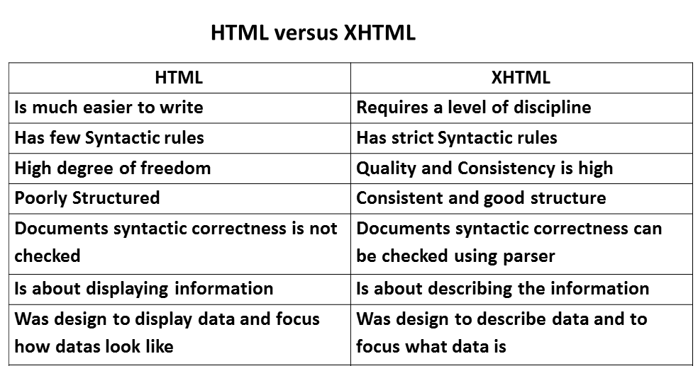

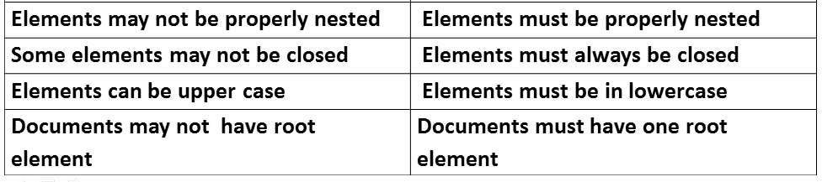

(0.5*8=4 Marks)

1. A text box to collect the user’s name

<input type=”text” name=”name” /> (1 mark)

1. Two checkboxes
2. Four 25W light bulbs for $2.39 (1 mark)
3. Eight 25W light bulbs for $4.29

<input type=”checkbox” name=”name” value=”value”/>

1. A collection of three radio buttons: (2 mark)
2. Visa

<input type=”radio” name=”name” value=”visa”/> visa

1. Master Card

<input type=”radio” name=”name” value=”mastercard”/> mastercard

1. Discover

<input type=”radio” name=”name” value=”discover”/> discover

1. MIME –document format is specified using MIME (1 mark)

MIME specifications have the following form:

type/subtype

The most common MIME types are text, image, and video. The most common text subtypes are plain and html. Some common image subtypes are gif and jpeg. Some common video subtypes are mpeg and quicktime. (3 marks)

1. Different image formats used for representing images

GIF- 8 bit, supports transparency

JPEG-24 bit, large no of color support

PNG- large no of color support, supports transparency (4 marks)

1. HTTP explanation (2 marks)

Request phase format (4 marks)

Response phase format (4 marks)

1. HTML code : (12 marks)

• Background of page is yellow bgcolor=”yellow”

• Title of the page is “gaming” <title>gaming</title>

• Text of whole document is verdana fontfamily=”verdana”

• Heading of the page is maroon and arial bold fontcolor=”maroon” fontfamily=”arial”

• Image used is “image1.jpg” <img src=”image1.jpg”/>

• border of table is green and of size 2

• background colour of table is white

• Image used in the table is “war.jpg” and “call.jpg”

• Horizontal line colour is black <hr/>

• Bottom link is “game.html” <a href=”game.html”>